**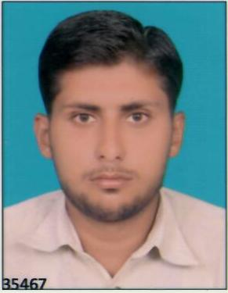 Curriculum Vitae**

Ghulam Meeran

Manama, Kingdom of Bahrain

Bahrain Cell: (+973) 3362 0853, 34030266

E-mail: [**ghulam.meeran50@gmail.com**](mailto:ghulam.meeran50@gmail.com)

**OBJECTIVE:**

Hard working, professionally committed, ability to take initiative, adaptability, ability to adjust in any kind of environment and a good team player.

**Experience**

|  |
| --- |
| ***Ahmad Sharif Furniture W.L.L Bahrain* C:\Users\usman\Downloads\11386518_455556207956755_927858725_a.jpg** |

**Purchase Assistant: - (From sep 2018, to till Today)**

* Dispatched/received all local purchase order to/from concerned authority.
* Prepared copies and faxed all local purchase order to suppliers, stores, workshops and branches.
* Encoded local purchase order number and purchase requisition with vendors.
* Attached invoices and delivery notes to local purchase ordered as well as checked the details of materials delivered.
* Coordinated with suppliers to ensure on-time delivery and receipt of invoices and delivery notes from them.
* Received (MRR) documents, verified numbers/dates and prepared list of documents to be sent to the accounting department.
* Executed and monitored all regular purchasing duties, including verifying petty cash fund and filing as well as securing confidential files of the company.

|  |
| --- |
| ***Pakson International Plastic Industry – Pakistan* C:\Users\usman\Downloads\BOSS.jpg** |

**Accountant: - (From Nov 2017, to till July 2018)**

* Maintain computerized accounting up to finalization.
* Handling petty cash, cash sales and bank transactions.
* Human Resources matters. (Employee record, their joining dates, terms & conditions of the employment. Employee date, leave record.
* Managing payroll for the company 200 employees.
* Posting the all kind of voucher i.e. journal Voucher, Bank Payment Voucher. Bank receipt voucher, cash payment, cash receipt voucher etc.
* Maintaining “Books of Account” General Ledger, Accounts Receivable and Accounts Payable.

**Strengths**

* Accurately managed a cash draw & deposit.
* Deal with diverse population/workers.
* Enthusiastic and cooperative.

Computer skills

Considerable practical experience in application and usage of the following computer software

* Microsoft Word, Excel, Access

E-mail, Internet etc. Financial Reporting System (Accounting software)

Education and Certification

**B. Com (ADP) Bachelor in Commerce, 2017,** University of Punjab- Pakistan

**I.Com**, Board of intermediate & secondary education, Gujranwala, Pakistan

**S.S.C**, Gujranwala Board, Pakistan

personal

**Date of Birth** February 02, 1994

**Nationality** Pakistani

**Marital Status** Single

**Interests** Play Cricket &, reading books